Student Getting Started Guide
Starfish ®
Version 6.4

Welcome to Starfish ®
Starfish provides you with a central location to connect to the people and services that can help you finish what you start – all accessible right from your Starfish Home page.
Log in to your Starfish Home page by going to [INSERT ACCESS POINT].
Your Home page includes access to a customizable profile and personalized channels that make it easy to schedule the dedicated time you need with your instructors, advisors or counselors. Starfish can also help you manage the steps you need to take to stay on track and meet your goals.
Here are three great ways to get started:
- Set up your profile
Make it easier for your instructors and advisors to get to know you and stay in contact.
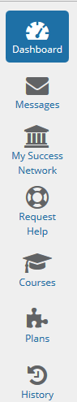
- Stay on track
Use your personalized Dashboard to stay on top of upcoming appointments, assignments, plans, and recommendations from your instructors.
- Connect to people and services that can help you
Use your personalized My Success Network and Courses channels for quick access to contact information, appointment scheduling, and course help.
Not sure what you need?
Browse the Services Catalog or use the Request Help option if you can’t find what you’re looking for through your personalized channels.

  - That’s it. Simple for you. Powerful for your future.

Set up your Profile
Begin by setting up your student profile. Your profile lets instructors and advisors know who you are and how to contact you. It also gives you control over how you wish to receive emails.
- Click your name in the top right corner of your Home page to open your profile.
From here, you can customize your profile by uploading a photo, setting appointment reminders, and adding a secondary email address for receiving Starfish emails (e.g. your mobile phone).
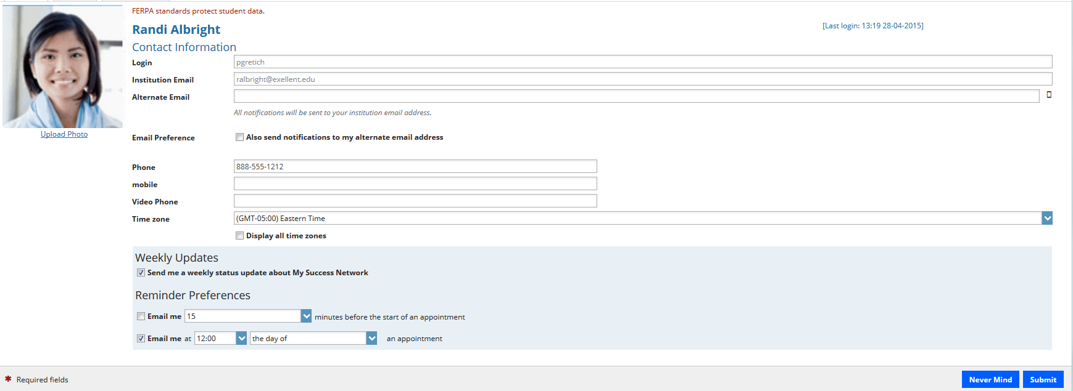
To have Starfish emails sent to your mobile phone (in addition to sending to your primary institutional email address):
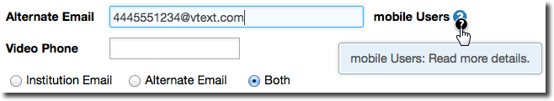
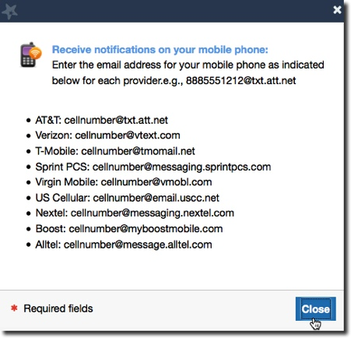
- Enter the email address of your mobile phone in the Alternate Email field. This address will be a combination of your phone number plus carrier information. Click the more information icon () for a list of common carriers and email address formats :
- Click the Both radio button associated with “Send my correspondence to”.

- Once you have made your desired changes to your profile, click the Submit button to save your updates.

Connect to people and services that can help you
The My Success Network and Courses channels display the people and services that are available to help you succeed. Here you can find key contact information as well as links to student service web sites and online appointment scheduling.

Messages
Click the Messages icon on your Home page to display messages sent to you in Starfish. Click on any message in the list to display the full contents of that message.
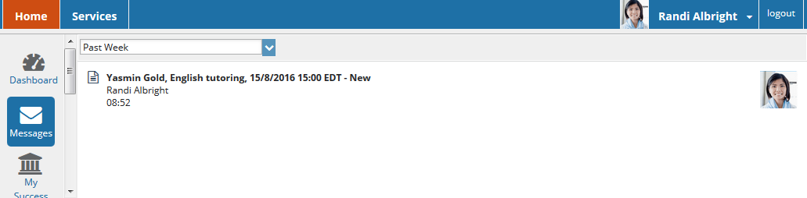

My Success Network
Click the My Success Network icon on your Home page to display your personalized network. This channel lists the people and resources that are available to assist you. (You can browse a broader list of available services in the Service Catalog). For each person or service listed you will find contact information, supporting websites, and, if online scheduling is enabled, a link to make an appointment. If a service includes a waiting room for walk-in appointments, you can click the “Waiting Room” link to find out how many students are currently in line.
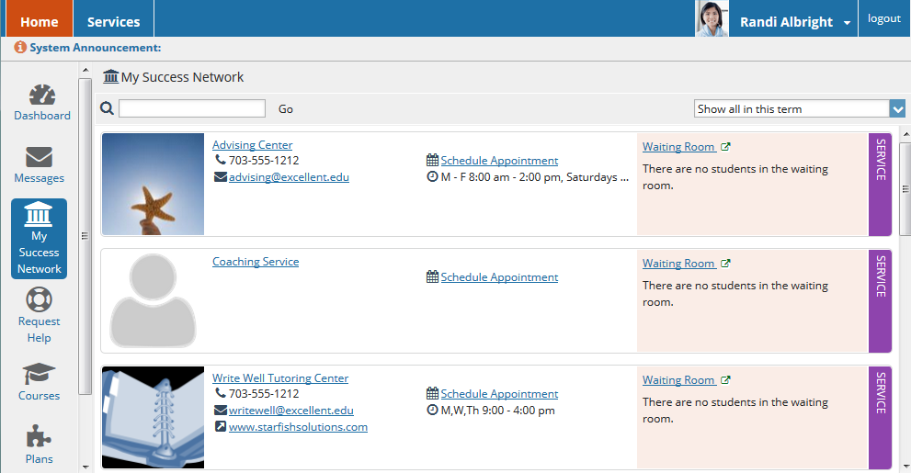

Courses
Click the Courses icon on your Home page to display information about courses you are enrolled in as well as contacts and available support related to each. Like the My Success Network channel, it is personalized to show the people and services specific to the courses you are taking, and gives you the ability to make an appointment or request help related to a course.

Make an Appointment
- Click the Schedule Appointment link below the contact information for the desired person or service in the My Success Network or Courses channel.
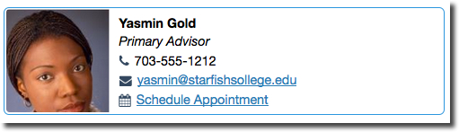
- Use the small calendar on the left to quickly identify days with available office hours (available days will be shown in bold). Click the desired date in the small monthly calendar to display availability on that day
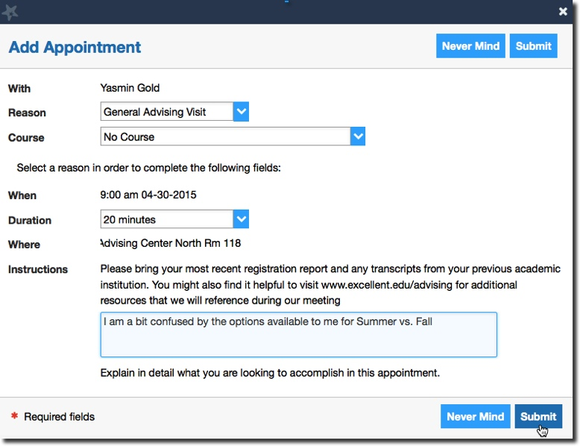
- Available time slots on the selected day will include a Sign up link. Click the Sign Up link associated with the desired time slot.
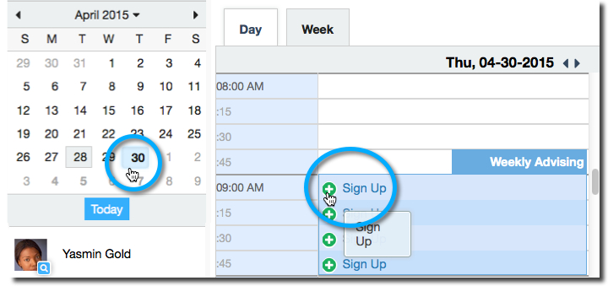

- This opens the Add Appointment form. Complete the form by selecting a reason for the meeting and a course (if relevant). Include an explanation of what you need so that your instructor or advisor can be prepared for the meeting.
- Click Submit to set the appointment. You will get an email with the appointment details and the appointment will be listed on your Dashboard.

Change an Appointment
Upcoming appointments will be listed on your Dashboard in the time line view (left column). Click the edit icon () to modify the appointment or the cancel icon () to cancel it.
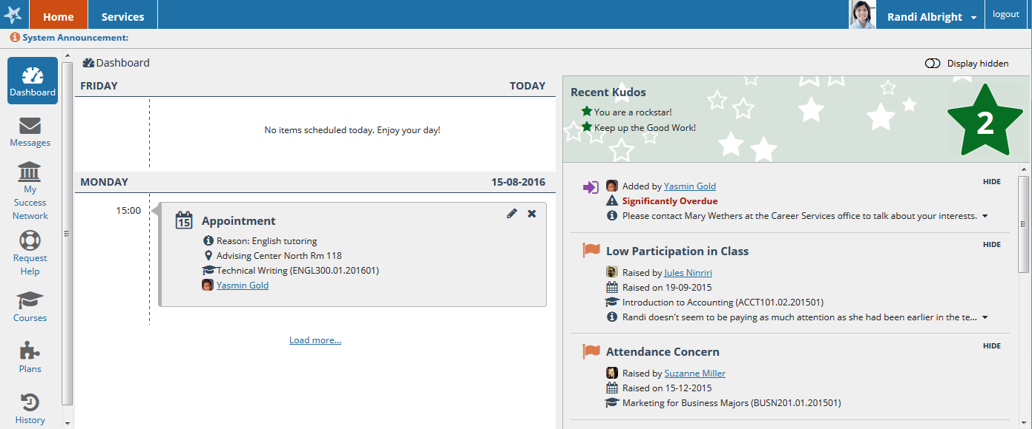

Request Help with a Course
Need help with a course, but not sure where to go? Request help with a course directly from the Courses channel.
- Click the Help icon () link in the upper, right corner next to any of the courses in which you are currently enrolled.
- This will bring up the Request Help form. Select the Type of help needed from the drop down menu and give specific Details on how staff can assist you.
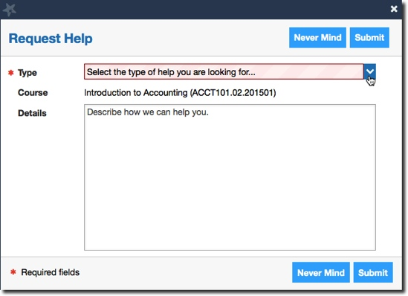
- Click the Submit button to submit your request when you are finished.

Stay on track

Dashboard
Your Dashboard displays upcoming appointments and date-based tasks on the left to help you plan your week. The right hand column of your Dashboard highlights items that require your attention and may include alerts related to your class work, recommended referrals to campus support offices to help you succeed, and Kudos from your instructors.

Messages
The messages will display the content of email messages sent to you through Starfish.

Plans
The Plans channel will display any customized Plans created for you by your advisor. This might include an Academic Plan or a more targeted plan for a set of specific tasks with due dates. Click the View Details button associated with a plan to display a printable version of the plan.
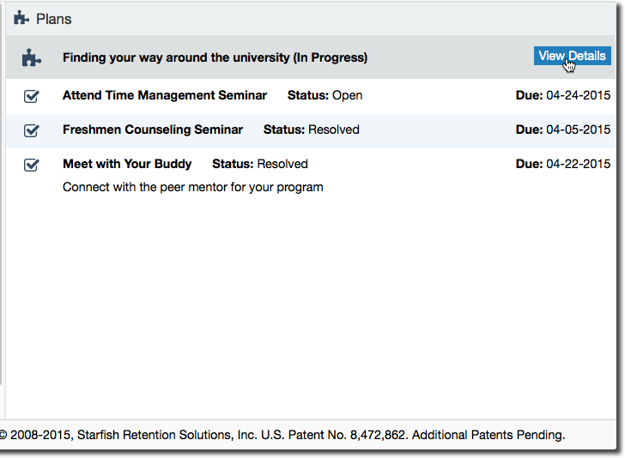

Not sure what you need?

Request Help
Click on the Request Help channel icon. Additional information about where to go for help will be displayed on the page. Click the Help Me button to submit a request for help.
You will be asked to provide additional information such as the type of help you are requesting, the related course (if applicable), and a description.
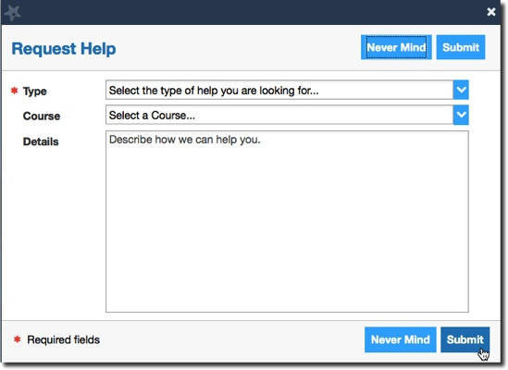
We encourage you to make your description as detailed as possible to insure you get the appropriate help needed. Click Submit to submit your request when done.

Services Catalog
Certain counselors and advisors may be listed in your personal My Success Network channel, but other individuals and services can be found in the broader Services catalog accessed from the top navigation bar. On this page you can search for a service or scroll through the list of available services. For each service you can, view contact information, visit service websites, and schedule online appoints (if available).
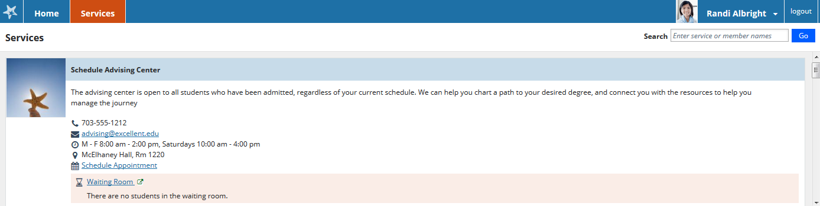

Frequently Asked Questions

What if I don’t see anyone listed in My Success Network?
Your specific advisors or counselors might not be assigned yet. Check back later or contact your institution’s help desk for additional assistance.

What if I click the Starfish link and get a “You do not have access” message?
Contact your institution’s help desk for assistance with accessing the Starfish system.

What if I need more help?
For technical issues, contact the Help Desk at 999-999-9999. For questions regarding a flag, please contact your instructor or advisor.

